Weekly Report Out 3

Team: Drone Link

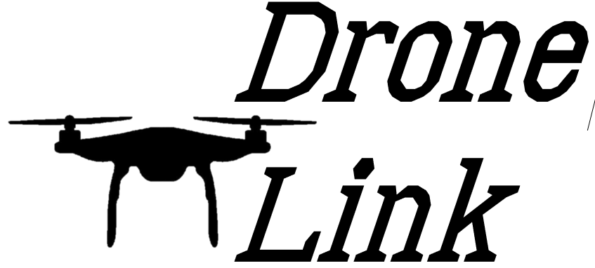Sam Forest, Alex Holt, Vincent Krenz, Lucas Larocco, Blake Masbruch

10/2/2020

Senior Design Adviser: Professor Wiedenhoeft

ScrumMaster: Vincent Krenz

Current Cadence: 1

**Progress**

We are finishing up Cadence 1 and have made wiki documents for most of our spikes, we will be finishing up the cadence over the weekend.

Sam Forest – This week I got the wireframe for the main page done and discussed with Alex more specifics for the Mock Timer.

Alex Holt – Getting architectural documents made , backlog grooming/creation, and closing tickets

Vincent Krenz – Created the Selenium wiki and POC, creation of testing document, working on creation of definition of done with team

Lucas Larocco – I looked at the advantages of each different iot protocol. In particular I read about how mqtt worked and started implementing an example.

Blake Masbruch – Created the baseline for our react application. This consisted of setting up setting up webpack to bundle the JS, and babel to compile from ES6 to ES5 standard. I also implemented redux for global state management within the web app, as well as other beneficial NPM packages. Implemented our backend framework, which we decided to be Express. This consisted of installing the express NPM package, implementing a ES6 to ES5 build conversion. This allows for us to write ES6 syntax and compile it down to ES5 which Express requires. Lastly, I made the application serve our static webpack with our injected React app onto port 3000.

**Future Progress**

Our future progress will be the completion of this Cadence and the grooming of Cadence 2’s backlog, as well as preparations for our retrospective which will include the learning of RetroRabbit. We will have all work done by Sunday to allow time for Alex to close tickets with the team

**Reflection**

Overall we have achieved a lot of progress on getting our bearings and preparing for future progress. We also look forward to learning from our retro on 10/7/20